**Project Mew**

Aaron Abon, Andrew Ng

CSE 111

**Synopsis**

Project Mew is a Pokémon based database that contains a select group of Pokémon from the first generation of games. This generation being Pokémon contained in the Kanto region of the Pokémon universe. It will list various details of Pokémon including number, name, type, stats and other specifications.

**UML Use Case Diagram**

The main use cases of our users using the Project Mew database would be to either search through the Pokédex or to create parties using Pokémon from the Pokédex. Browsing the Pokédex can be used to: generally browse pokemon, or browse by certain details such as by BST (Base Stat Total), number, evolution(s), specific stat, or type in which type could have two possible types, but at least have one type. The admin manages the Project Mew database by either adding/deleting Pokémon or types to the Pokédex.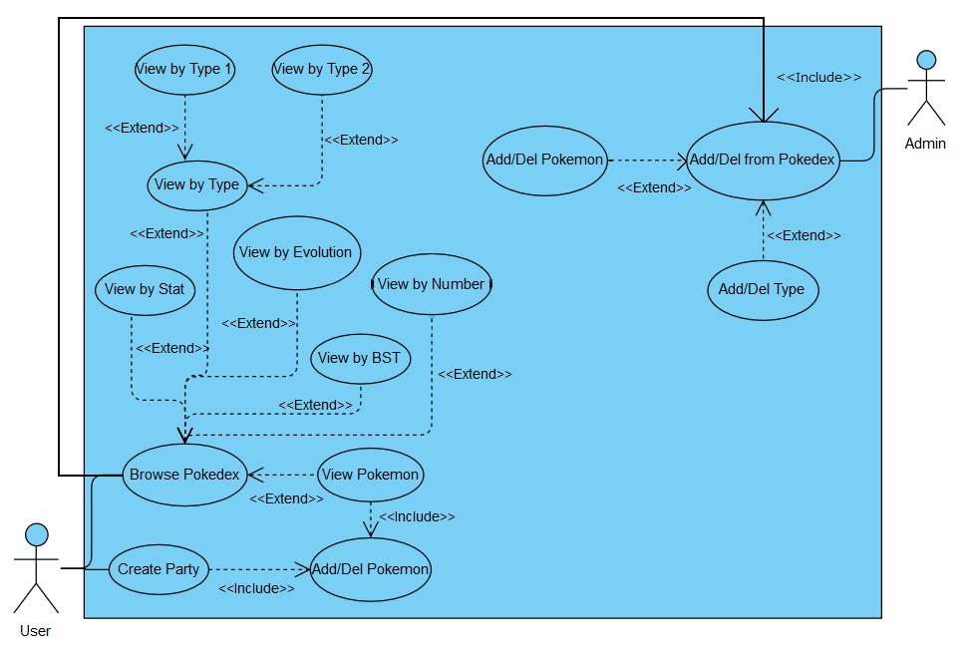

**ER Diagram**

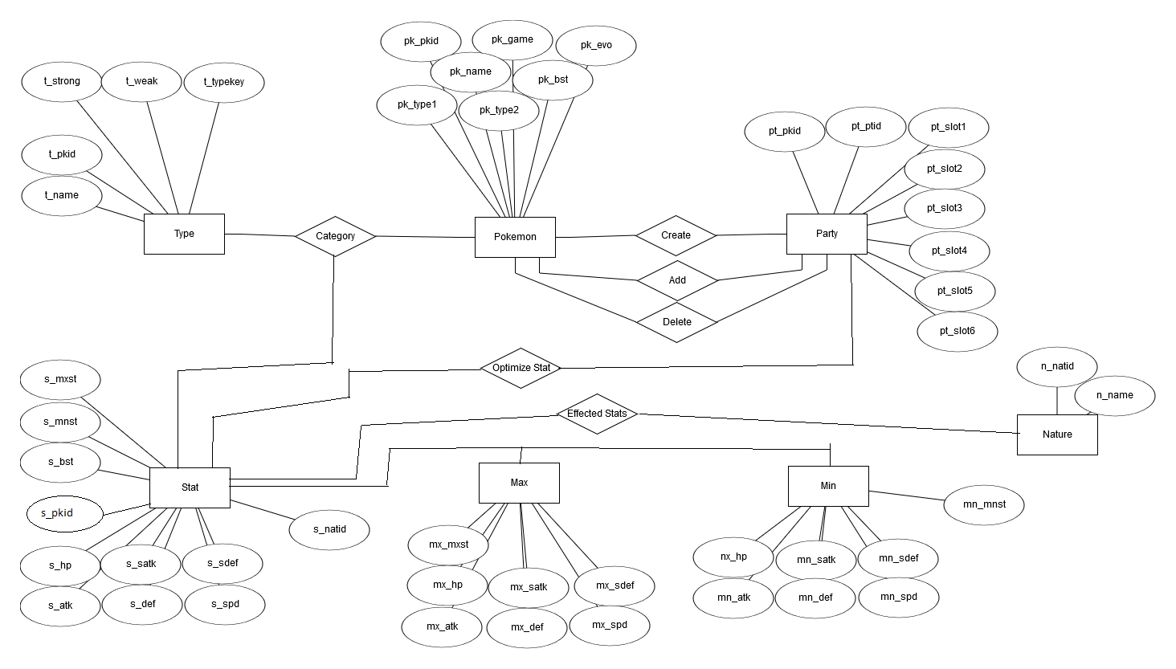

**Relational Schema**

|  |
| --- |
| **Pokemon**(pk_pkid, pk_game, pk_evo, pk_type1, pk_typ2) Create(pk_pkid, pt_ptid) Add(pk_pkid, pt_ptid)  Delete(pk_pkid, pt_ptid)  **Party**(pt_pkid, pt_ptid, pt_slot1, pt_slot2, pt_slot3, pt_slot4, pt_slot5, pt_slot6  Optimize Stat(pt_ptid, s_bst)  **Stat**(s_pkid, s_mxst, s_mnst, s_bst, s_hp, s_atk, s_satk, s_def, s_sdef, s_spd)  **Max**(mx_mxst, mx_hp, mx_atk, mx_satk, mx_def, mx_sdef, mx_spd)  **Min**(mn_mnst, mn_hp, mn_atk, mn_satk, mn_def, mn_sdef, mn_spd)  Category(s_bst, t_name, pk_pkid)  **Type**(t_pkid, t_name, t_strong, t_weak, t_typekey)  **Nature**(n_natid, n_name)  Optimize Stat(s_bst, pt_ptid)  Effected Status(n_name, s_bst) |

